# CONNECTION IN WOKWI FOR THE

**ULTRASONIC SENSOR**

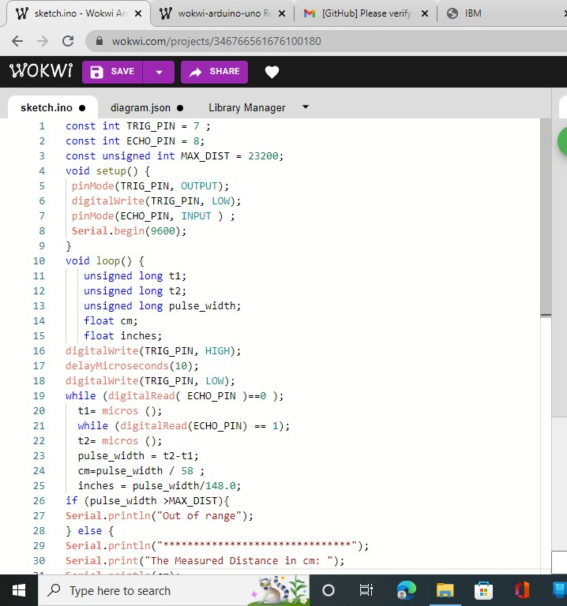

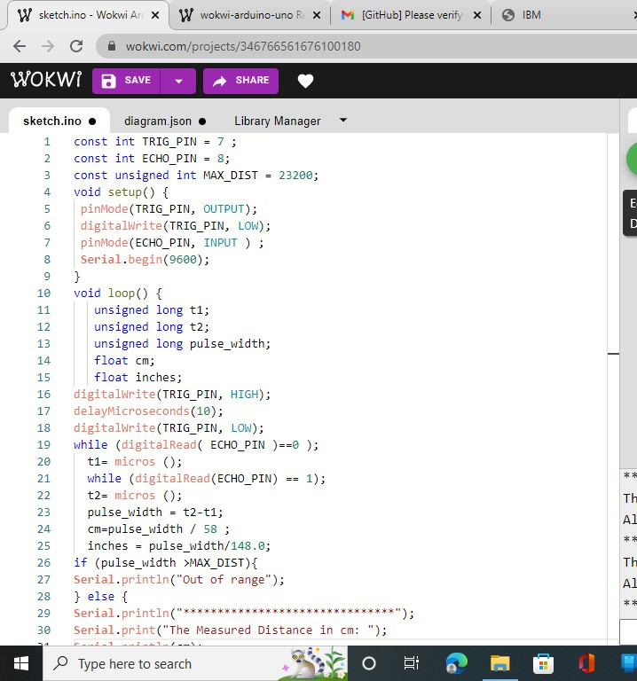

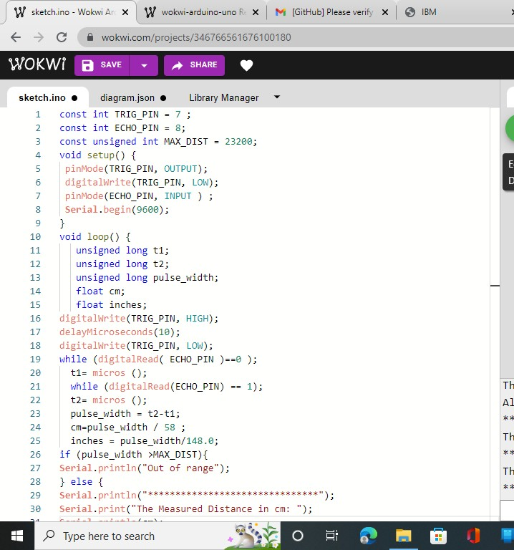

# CODING:

const int TRIG_PIN = 7 ; const int ECHO_PIN = 8;

const unsigned int MAX_DIST = 23200;

void setup() { pinMode(TRIG_PIN, OUTPUT);

digitalWrite(TRIG_PIN, LOW); pinMode(ECHO_PIN, INPUT ) ;

**Serial**.begin(9600);

}

void loop() { unsigned long t1; unsigned long t2;

unsigned long pulse_width; float cm;

float inches; digitalWrite(TRIG_PIN, HIGH); delayMicroseconds(10); digitalWrite(TRIG_PIN, LOW);

while (digitalRead( ECHO_PIN )==0 ); t1= micros ();

while (digitalRead(ECHO_PIN) == 1); t2= micros ();

pulse_width = t2-t1; cm=pulse_width / 58 ; inches = pulse_width/148.0;

if (pulse_width >MAX_DIST){

**Serial**.println("Out of range");

} else { **Serial**.println("*******************************"); **Serial**.print("The Measured Distance in cm: ");

**Serial**.println(cm); if( cm < 100 ){

**Serial**.println("Alert!!");

}

**Serial**.print("***********************************");

}

delay(1000);

}